


Singleton Church of England Primary School

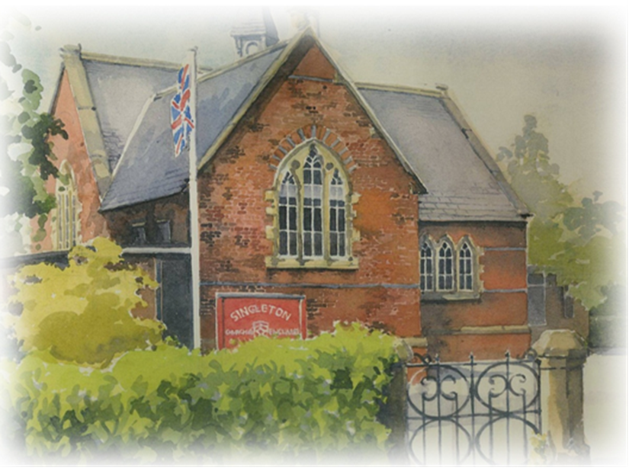
Parent Handbook / frequently asked questions

“Passion for learning …. Passion for life”

Vision

“With God all things are possible” Matthew 19:26

“I have come so that they may have life and have it to the full” John 10:10

To provide the children with a variety of challenging and enriching opportunities, enabling them to live life to the full. Developing a growth mind-set, believing that with God everything is possible. To show, love, trust, wisdom and respect, becoming exemplary role models in our community and the wider world.

The Singleton School Overview
Singleton C of E Primary School strives to provide a well-rounded education for our children within a stimulating, fun learning environment. We believe that all children who become pupils at our school deserve the best Christian Education and we have the highest expectations of pupil attainment, teacher performance, governor performance, support staff performance and parental involvement. We encourage everyone to strive for excellence and achieve their full potential.

Welcome to Singleton C of E School
Welcome to Singleton School. We hope that you and your child will enjoy the time you spend with us and find this information useful. Please read this booklet carefully to help you and your child achieve a successful start at Singleton.

At Singleton School, we strive to provide a well-rounded education for our children within a stimulating, fun learning environment. Our school is a diverse and wonderful community, and our curriculum provides equality of opportunity for all. We are incredibly proud of our little school, and we believe that all children who become pupils at our school deserve the best Christian Education. We have the highest expectations of pupil attainment, teacher performance, governor performance, support staff performance, and parental involvement. We encourage everyone to strive for excellence and achieve his or her full potential. We believe that every child should be given opportunities to thrive socially, emotionally, academically, and physically. The sky is the limit for our children. We seek to inspire each other to learn to value difference, greatness, ambition, and achievement of all kinds.

There is a shared commitment to a clear vision. The vision has a strong focus on our Christian Values. All staff buy into our vision that incorporates ‘passion for learning, passion for life’. Staff aspire to create learning opportunities for our children that inspire them to be proactive, independent learners and to strive to be the best that they can be.

Our curriculum, vision, and values have been further developed into our C A R E ethos that encourages all of us (adults and children) to make the right choices, aspire highly, and reflect and engage in their academic and spiritual learning as well as in their character development so that they can achieve success in all areas of their lives.
Our Care Ethos is rooted theologically and practically in our shared commitment to seeing every child as beloved and made in the image of God. Thus, enabling them to flourish and live life in all its fullness.
The C A R E ethos for our school is our curriculum driver, and it links to our Vision and Values. It is about creating the right culture with positive relationships at the heart of everything that we do. We value and treasure every individual, and we take great pride in watching one another grow.
We want our pupils to understand what it means to be part of the ‘Singleton Family’, to wear their uniform with pride, to embrace every opportunity, to have a growth mind-set and aspirations and to feel valued, nurtured, and happy.

At the heart of our curriculum is ‘knowledge and skills’. All children are exposed to creative, sporting and cultural opportunities, along with a rich diet of extra-curricular activities and class visits. We pride ourselves on offering a challenging and engaging curriculum where children have the opportunity to develop a greater depth of knowledge in Maths and English, but just as importantly we provide a creative and engaging skills-led curriculum, where children are immersed in a world of construction, sports and sciences. Further to this, our school provides first class performing arts and music opportunities, as we believe these skills are an integral part of the curriculum as well as providing many additional opportunities within individual lessons.

Our curriculum is designed to enrich the lives of our pupils, alongside facilitating the development of literate, numerate, pupils who are solvers of problems; true to their faith; caring of others and of their environment. We promote ‘Limitless Potential’ and embrace pupils who are creative, appreciative of the arts and performing arts, dedicated to sport, fascinated by science. We encourage ambitious pupils, who are motivated and believe in their abilities.

Our curriculum develops our pupils in ways that go far beyond the academic. It is enriched by opportunities for, spiritual growth, personal and moral development, living safely, cultural awareness and personal challenge.

Our pupils’ knowledge must be secure and provide a strong foundation for their future learning and progression, supported by individualised and meaningful provision throughout their time at our school. Academic, vocational, creative and technical experiences are offered and celebrated with equal distinction. For example, STEM, Forest Schools, and Musical Theatre.

Within our school, we work very hard to create a passionate team of teachers, non – teaching and support staff that will support each child in reaching their full potential. Many who visit us comment on the strength of our staff team and their shared commitment to help every child in the school achieve their best. For us our philosophy of education is simple in that we want the best for all our children and we want to create a learning environment that encompasses our ‘Passion for Learning and our Passion for Life’.

We see ourselves at the heart of the community and are proud of the strong links we have with local community groups and businesses and the use we make of local resources such as our local church, woodland areas and museums.

We hope that as you read our Parent Handbook you will gain a sense of the value that we place in every child and our desire to ensure standards, in all areas, remain as high as possible within the caring and happy community that is Singleton C of E Primary School. At Singleton C of E Primary School, we are very fortunate to have a supportive and friendly parent body. Our parents recognise that educating children is a process that involves partnership between parents, class teachers and the school community.

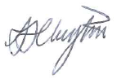
Kind regards,

Head teacher

Introducing Some Key People
Role | Name | E-mail where applicable
Head Teacher | Mrs A Clayton | head@singleton.lancs.sch.uk
Foundation | Ms L Rund | lisa.rund@singleton.lancs.sch.uk
Class 1 Teacher | Mrs R Warner
Class 2 Teacher / SENCO | Mrs L Millward
Class 3 Teacher | Mrs K James
Higher Level Teaching Assistant | Miss S Kirby
Teaching Assistant | Mrs J Morgan
Musical Theatre Teacher | Mrs N Brooke
Teaching Assistant /Learning Mentor | Miss S Manns | Susan.manns@singleton.lancs.sch.uk
Office Manager | Mrs R Reeves | head@singleton.lancs.sch.uk
Business support officer | Ms J Stansfield
Cook | Mrs Carolyn Haven
Kitchen Assistant | Mrs Rachel Kearton
Welfare Assistant | Mrs J Morgan
Welfare Assistant | Miss S Manns
Welfare Assistant | Ms J Stansfield
Acorns out of hours club | Mrs S Goldie | Sarah Goldie TEL: 07860816175  EMAIL: sarahgoldieuk@outlook.com
Acorns out of hours club  Day to day lead | Miss G Magowan
Acorns Club Assistant | Miss H Towne
Site Supervisor | Mr A Lythgoe
Vicar | Rev M Keighley
Chair of Governor’s | Mr A Davies

Communication
- Our school office is open from 8 am until 4.15 pm (Friday 8 am -3.45 pm)
- Please note it is closed for lunch between 12 – 1pm each day
- Tel: 01253 882226
- Please note that there is an answerphone system in place, which is regularly checked.
- E-mail; - head@singleton.lancs.sch.uk
If we wish to contact you: -
- By telephone – Please ensure that we always have correct contact numbers, including for emergency contact.
- By e-mail: - Almost all school letters and other information are sent to you electronically. Please check your e-mail account on a regular basis and let us know if you are not receiving anything or if we need to update your e-mail address.
- By Text – we use this service for general day-to-day reminders or for urgent messages
- Facebook – This is used more as an information platform to see/hear about the events in school
- Foundation Stage only – Class DoJo
Website
- We encourage all parents to access our website. It contains a lot of information that is relevant during the time your child is at our school.
- It also contains a virtual office, which is useful for forms and holiday dates, etc
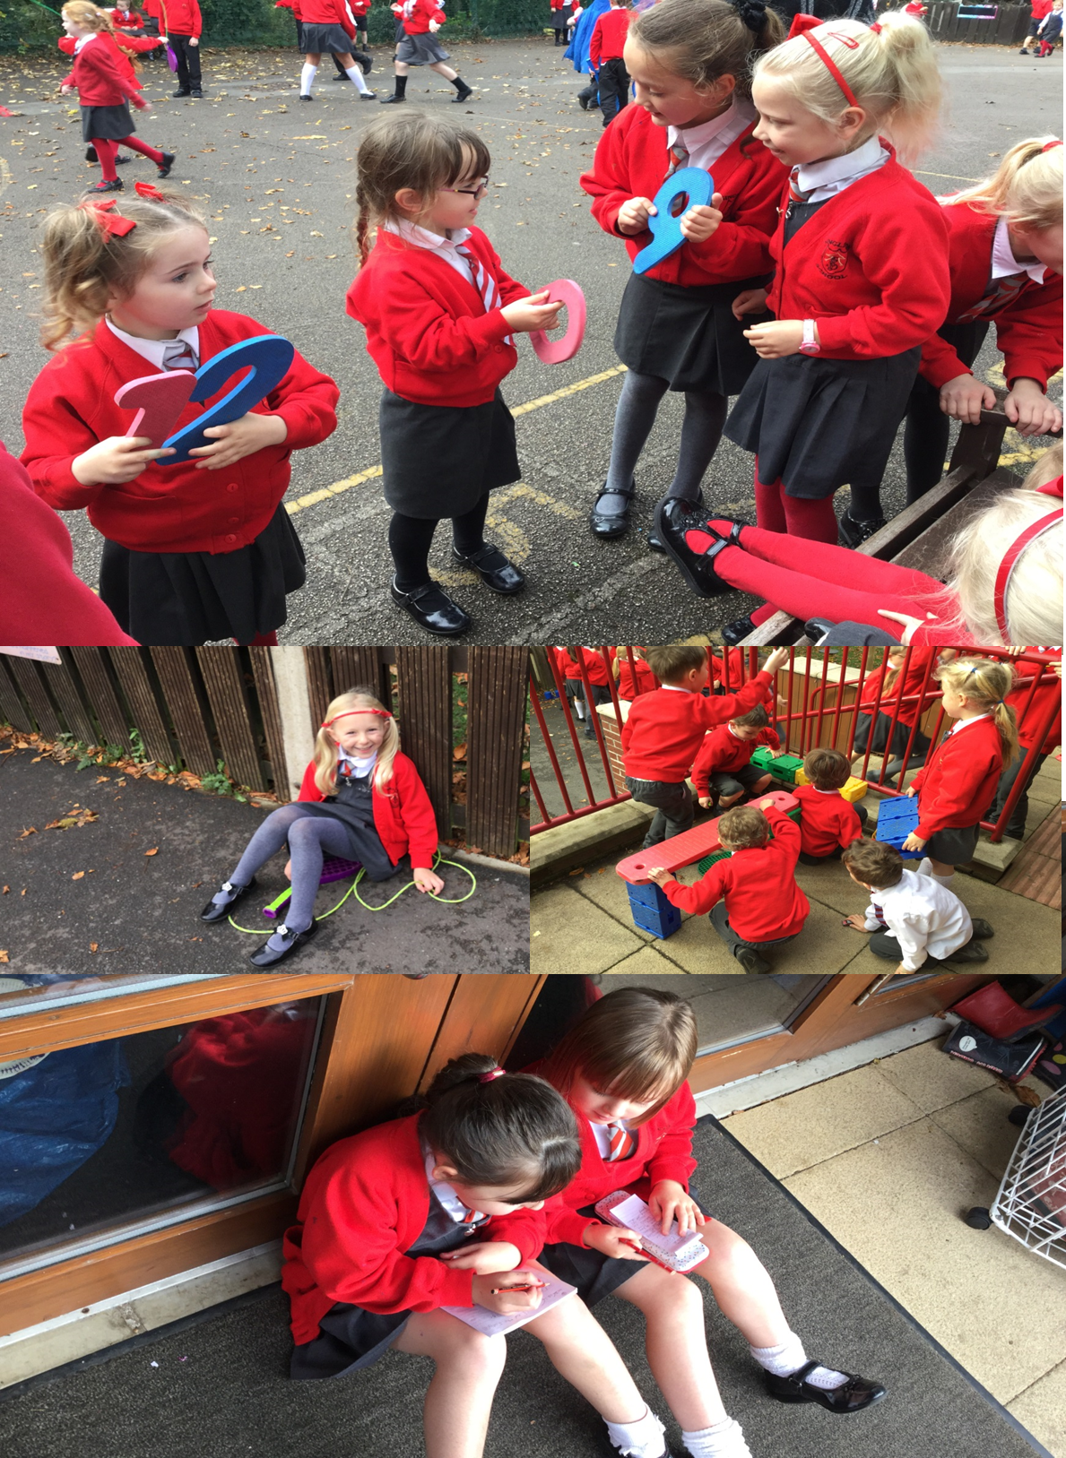

YOUR CHILD’S LIFE AT OUR SCHOOL
An ‘A-Z’ of Basics
The following document is designed to provide you with additional information to help you and your child to settle in at Singleton C of E School quickly.
Absence / Attendance
- Doors open 8:40 am
- Registration closes at 8:50 am
- End of school day 3:15 pm
- This equates to 32 hours and 30 minutes a week.

How we manage lateness:
- The school day starts at 8.40 am when children come into school.
- Registers are taken by 8:50 am, and your child will receive a late mark ‘L’ if they are not in by 8:50 am.
- Children arriving after 8.40 am are required to come into school via the school office. If accompanied by a parent/carer, they must sign them in and provide a reason for their lateness, which is recorded.
- At 9.10 am the registers will be closed. In accordance with the Regulations, if your child arrives after that time, they will receive a mark that shows them to be on site – ‘U’, but this will not count as a present mark and it will mean they have an unauthorised absence.
- The school may contact parents/carers regarding lateness.

Do I phone the school if my child is sick?
Yes, please phone the school office or leave a message on the answer machine by 9.10 am. It is imperative that you do this so that we know your child is safely with you and not been abducted on route, unbeknownst to all of us! Please send a letter to the school when your child is well enough to return.
Where children are unwell and not fit to be in school, and where they are still suffering from an infection which may be passed to others, children should remain at home to be cared for and looked after. Even if they have improved, children may not return to school for at least 48 hours into a course of antibiotics.

Please do not send any medicines or throat lozenges into school with your child – especially not in your child’s bag!!! Children who are ill need to stay at home. On our website there is guidance for parents on illness and guidelines as to how long a child needs to be kept off school.

Can I Take My Child on a Family Holiday During Term Time?

No, You Cannot
- Change in Law (2013, Updated 2024): The school cannot authorise time off during term except under very rare circumstances.
- Penalty Notices: Parents might get fined if their child’s absence exceeds the threshold and is unauthorised.
- Prosecution: Taking 15 or more days of unauthorised leave can lead to prosecution to ensure regular school attendance.

Important Points of the New Attendance Framework
- Penalty Notices: Considered on a case-by-case basis if the absence meets the threshold.
- Prosecution for Unauthorised Leave: 15 or more days of unauthorised leave may lead to prosecution to stress the importance of attendance.
- Compliance with New Framework: The school follows the advice of Lancashire County Council to meet legal requirements.

Legislative Compliance
- New DfE Guidance: The school must comply, including fining parents for unauthorised absences.
- School's Responsibility: The governing body will consider each case individually and apply fines where appropriate.

Holiday Requests in Term Time
When considering holiday requests during term time, the school will evaluate:
- Timing of leave (e.g., during assessment periods).
- The pupil’s attendance record, including previous unauthorised absences.
- Whether the leave might exacerbate attendance concerns.
- Any other leave taken during the current or previous academic year.
Holiday request forms are available on the school website. These need to be returned to the school via the office drop box six weeks before the holiday. The Governors meet once a month with the Head Teacher to discuss holiday requests. As part of the process, you will likely be invited to meet with the Head and representatives from the governing body to discuss the holiday request and its implications on your child’s learning. Unless there is an extenuating circumstance, your holiday request will not be authorised.

Exceptional Circumstances
If you are applying for an exceptional circumstance holiday request or absence, evidence must be provided, such as written confirmation from employers to confirm that a holiday cannot be taken at another time. Contact details for the evidence providers must also be included with the application. Without evidence, it is unlikely that an exceptional circumstance will be granted.

The Importance of School Attendance
Children have 13 weeks of holiday per year and need to be learning in school. Taking work away with you is no substitute, and we do not set work for children who are taking term time holidays.

Extended Holidays and Personal Family Commitments
If a holiday or personal family commitment extends over the holidays, you need to complete a holiday/family leave request form. These forms are available on the school website and need to be returned to school via the office drop box at least six weeks before the requested leave.

Absence from School
By law, schools must record absences and the reasons given for the absences. In our school, the SHE committee of the Governing body, along with the Head Teacher, consider absence requests. Parents/carers provide reasons for absence, and the school must decide whether or not they justify authorisation according to government guidelines.
Examples of Authorised Absences:
- Genuine illness of the pupil
- Hospital/dental appointment for the pupil
- Death of a near relative
- Religious observance (faith of the parent/carer)
Examples of Unauthorised Absence:
- Shopping trips
- Birthday treats
- Oversleeping due to a late night
- Letting the gas man in
Whenever a child is absent from school, the parent/carer should:
- Contact the school before 9:10 am on the first day of absence. If no notification of absence is received, the school office will contact the parent/carer to ascertain the reason.
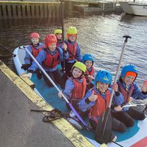
- Where possible, make medical/dental appointments out of school hours.
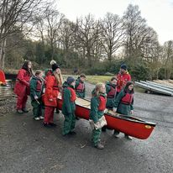
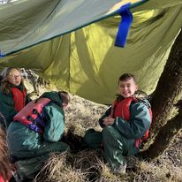

- Where possible, let the school know in advance of any planned absences (e.g., hospital appointments).

Academic Progress
How will I know about my child’s progress?
In various different ways:
- Reading records track reading progress
- Open afternoons (3 per year – where you can look at books and complete activities with your children)
- Formal Parents Evening – November /March
- Curriculum Newsletter
- Conversations before and after school
- Newsletters
- End of Year Reports – Full detailed overview

Children are assessed using a variety of methods throughout the year, and class teachers monitor progress carefully. Individual assessments are not reported to parents as they need to be taken as a whole over the course of the year – they are not reliable when taken out of context.
However, parents will be informed of progress three times a year, at the formal Parents Evening and through the school report at the end of the year.
Class teachers will contact parents if they feel, after additional support and interventions, that children are not progressing academically as expected or they have concerns about the social, emotional and behavioural wellbeing of a child.

All assessments are reported to Mrs James (Assessment Lead), who charts progress over time and looks for any underachievement. She, along with the SENCO (Mrs Millward), ensures that additional provision/support is put in place for children who appear to not be making expected progress or children that the teachers feel just need a bit of extra consolidation. This additional support takes place in the afternoon in small groups or on an individual basis, depending on the needs of the child. We currently run four provision maps: -

- Cognition and Learning
- Communication and Interaction
- Emotional, Behavioural and Social
- Sensory, Physical and Memory

If children are underperforming due to a family circumstance, The Head / Assistant Head and the Family Learning Mentor will support both the family and the child.

If your child is on the SEN register, you will receive 3 meetings a year at the beginning of each term with the class teacher. These meetings are essentially an opportunity to work with the teacher to establish how best to support your child and to go through the Individual Educational Plan (IEP) to review progress against targets and set new targets.

All parents are welcome to discuss concerns about achievement with their child’s class teacher. However, please be aware that we would contact you if we were concerned.

Why are parents only informed of progress three times a year?

Because progress takes time to happen! Learning takes time to embed, and children need time to practise. You are welcome to contact your child’s class teacher for an update, especially if you are concerned, but please don’t expect startling improvements to happen on a weekly basis.

Please don’t ask every day or every week as with 30 children in a class, it is not reasonable or possible for the teacher to give such regular updates.

Assemblies /Worship
Can you tell me about the collective worship offered at Singleton School?

All our collective worships are underpinned by our Christian values. We aim for pupils to leave our school with a rich experience and understanding of Christianity. We are committed to offering them an encounter with Jesus Christ and with Christian faith and practice in a way that enhances their lives. Our collective worship includes prayer, reading and reflecting on the Bible, liturgy, sacrament, and experiencing the musical and other imaginative riches of Christianity.

Worship is organised as follows:
- Monday – Whole School Family: Introduction to weekly worship theme/bible story - Includes prayer, sung praise, Bible reading, and reflection.
- Tuesday – In Class: Based on Christian values/current world issues. Worship with song, prayer, stillness, worship, and reflection with sung praise.
- Wednesday – In In-class worship: Supported by the worship leaders. Worship with song, prayer, stillness, worship, and reflection with sung praise.
- Thursday – Whole School Family (Clergy Led): Singing, Bible passage/reflection/prayer – linked to Sunday worship and the Church's calendar of key events.
- Friday – Whole School Family (Celebratory Worship): DOT Assembly (linked to Growth Mindset) - Joyful Worship – Celebration (Weekly theme – threaded through planning) - whole school. Includes prayer, sung praise, and reflections.

Worship is planned for the whole year by the Headteacher and RE lead. The worship plans are organised into 6 terms and worship is planned on a weekly theme. The staff have a daily worship plan as a starting point, which they can modify to meet the needs of their children

Can I come to watch an Assembly / Worship?

Parents are valued and are invited to join us for worship in Church and for the ‘Celebration Worships.’ Celebration Worships – These take place once a term for each class. The classes lead the worship, and parents are invited to join and share in these experiences and stay for a cup of tea and a biscuit afterward.

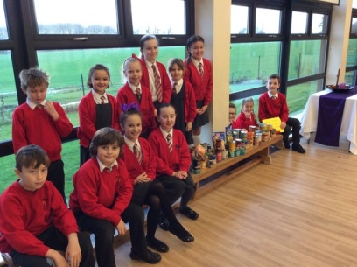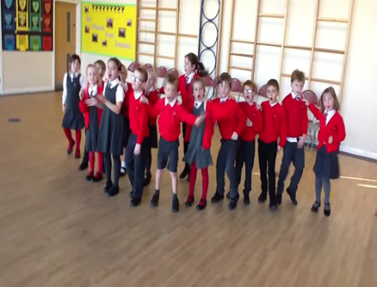
Behaviour
Low-Level Behavioural Issues

Our staff are excellent, and the rule of thumb is that they deal with all low-level incidents – these are incidents that we deem to be ‘normal’ for their development age. For example, at four, this can include pushing, lashing out, etc. The staff will not report every low-level incident to parents, just as they wouldn’t tell you every time a child got a sum wrong. However, they do deal with these incidents and teach the children how to behave.
Children also fall out with each other; this is part of growing up and we take our role of teaching children how to get along with each other very seriously.

Playground spats do happen, sometimes resulting in minor injuries. We investigate causes, inform parents if we consider the incident to be serious, and work hard to both resolve conflicts and teach children how these can be avoided in the future.

We all want children to enjoy coming to school and learning. If an incident is more serious, we would contact parents and work with you.

My child has been told off – who do I see about this?

Very few children have been excluded from Singleton School, and we rarely have behaviour problems. However, all children misbehave at some point – they’re children, and it’s normal!

We co-parent with you, and children are not the finished product. They need guidance, checking and to know what the boundaries are for good behaviour. When they’ve crossed the line, they need to know to develop and learn. If the staff feel that the incident is more serious, then they will contact you; however, if it was just a low-level incident, this will just be dealt with in school by the staff.

Every day is a new day in school, and our staff always treats the children in a balanced, fair way. Please expect your child to be in trouble at some time during their time at Singleton and trust that we will tackle the situation with your child’s interests at heart.

Should poor behaviour become prolonged, the Family Learning Mentor will work with you and introduce a support programme to help your child. We rely on parental support over incidents. If you require clarification, it is better to make an appointment to see your child’s teacher after school. In the morning, class teachers are setting up for the day and seeing their classes into school, however, they are available after school from 3.20 pm once they have safely released all the children to their parents/carers. We ask that you do not try to justify or make excuses for inappropriate behaviour; we need to be a united team in terms of establishing boundaries with our children.

However, as explained earlier, we do deal with all low-level incidents and do not report every incident to parents, just like we wouldn’t if a child got a sum wrong in maths. We constantly teach the children how to behave appropriately, and as with any learning, this takes time. Children have to be given the opportunity to learn from their mistakes. We will inform you if behaviour becomes a concern as we feel that at this point, it is vital that the children see that this is actually serious and we are working together as a team.

For more serious incidents, the school will contact you to arrange a meeting with the Family Learning Mentor or, if the incident is very serious, Mrs Clayton.

What do I do if another parent has told my child off, and I am not happy?
At our school, we have a Parent Code of Contact Policy that outlines the following: -
Expectations:
- That adults set a good example to children at all times, showing them how to get along with all members of the school and the wider community.
- That no members of staff, parents, or children are the victims of abusive behaviour or open to threats from other adults on the school premises.
- Physical attacks and threatening behaviour, abusive or insulting language, verbal or written, to staff, governors, parents and carers, children and other users of the school premises will not be tolerated and will result in the withdrawal of permission to be on school premises.
- Any parent who is asked to leave the school premises will have the right to appeal the decision by writing to the Chair of Governors.

Types of behaviour that are considered serious and unacceptable and will not be tolerated towards any member of the school community:

This is not an exhaustive list but seeks to provide illustrations of such behaviour:
- Disruptive behaviour that interferes or threatens to interfere with the operation of a classroom, an employee’s office, office area, or any other area of the school grounds.
- Shouting, either in person or over the telephone
- Intimidating behaviours, including displaying temper
- Inappropriate posting on Social Networking sites - e.g., deemed as bullying or personal/derogatory towards members of staff
- Defamation of the school’s or staff's character on Facebook or other social sites
- Speaking in an aggressive/threatening tone
- Physically intimidating, e.g., standing very close
- The use of aggressive hand gestures/exaggerated movements
- Physical threats
- Shaking or holding a fist toward another person
- Swearing
- Pushing
- Hitting e.g., slapping, punching, or kicking
- Spitting
- Racist or sexist comments
- Unwarranted and unnecessary correspondence taking up undue teaching and administrative time.
- Abusive or threatening e-mails or text/voicemail/phone messages or other written communication.
- Approaching someone else’s child to discuss or chastise them because of their actions towards another child. (Such an approach to a child may be seen to be an assault on that child and may have legal consequences).
- Using loud, rude, or offensive language or making malicious comments.

If you witness or are on the receiving end of any of the above, then you should let the school know immediately, as we take this very seriously.
Bullying
I think my child is being bullied - what can you do?
We regard bullying as a very serious issue. Bullying is sustained, mental, or physical abuse. It is not a playground spat, a falling out between friends, or infants tumbling over each other and learning to take turns, etc.

Children who are being bullied change over time, often becoming more and more withdrawn and experiencing disturbed sleep. Their confidence erodes, as does their self-esteem. It is vital that we recognise any signs as soon as possible and act quickly to stop it.

If you are concerned, contact the class teacher or the Family Learning Mentor. We very rarely have cases of bullying at our school. Often, the children have just fallen out with one another or are playing in a rough manner – but if this is the case and your child is upset, we still need to know!

Charging Policy
As a school we seek to meet the costs of all educational activities undertaken by pupils from our delegated school budget. However, from time to time and in the case of some extra-curricular activities, Educational and Residential visits, we may ask parents to offer a voluntary contribution to the costs of these valuable experiences. These costs are communicated to parents well before the event, and helping with the costs enables us to offer a much wider range of such activities.

No child will be excluded if they have not paid; however, the school wishes to make clear that should insufficient funds be raised to cover the costs, then visits will be cancelled.

Curriculum letters
What is a curriculum letter?
At the beginning of each term, we will send you a letter to tell you what your child will be learning about. Often, we put pleas for things in this letter, such as junk materials, parents to help, and old materials. You must read this letter so you know what your child is doing in school each day. Parents do not have access to teachers’ lesson plans.

Dinner Money
When do I pay dinner money?
Infants are now all entitled to a universal free school meal. For the rest of the school, parents pay 1/2 termly in advance.
As we are a cashless school, all dinners can be paid for by ParentPay,’ Login in’ details will be given when your child starts. The school dinner amount can be seen in the School Newsletter and on your ParentPay account.
- All dinners must be paid for before the start of the new half term (so in advance).
- If your child is absent, then you will be credited with the cost of the meal and pay less the following term.
- If you decide to change to a packed lunch, then we will need to be notified at least one week in advance to allow the cook the time to change her order.
Ad Hoc
- If you need to book a meal on an ad hoc basis the office must be informed by 9.15 am and the payment of £2.50 to be made on ParentPay.

Please see Mrs Reeves if you think you may be entitled to free school dinners for your child and she will advise you further as school will receive additional money if they are on free school meals. This will provide additional benefits for your child; e.g. one free after school club per week and some funding towards a school trip in addition to providing your child with additional support in class.
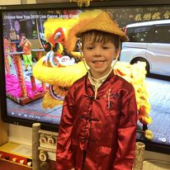
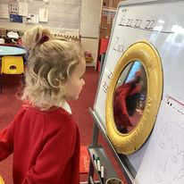
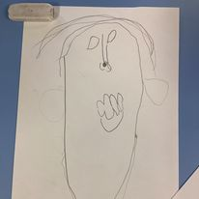
Please be aware that there is a difference between the universal free school meals that all infants are entitled to and ‘Free School Meals.’ Even if your child is in the infants and receives universal free school meals, you must apply separately for the free school meals to receive the additional funding.
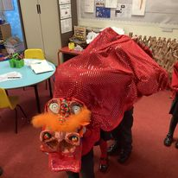

How much notice do I give when changing from dinners to packed lunches?
- At least one week’s notice! This is because the kitchen orders food one week in advance.

Drop off and Collection Policy
- Doors open 8:40 am
- Registration closes at 8:50 am
- End of school day 3:15 pm
- Which equates to 32 hours and 30 minutes a week.

How we manage lateness:
- The school day starts at 8.40 am when children come into school – we expect all children to be in school at this time
- Registers are taken by 8:50 am, and your child will receive a late mark ‘L’ if they are not in by 8:50 am
- Children arriving after 8.40 am are required to come into school via the school office. All children need to be accompanied by a parent/carer, and they must sign them in, providing a reason for their lateness, which is recorded in the ‘Late Book’.
- At 9.10 am the registers will be closed. Following the Regulations, if your child arrives after that time, they will receive a mark that shows them to be on site – ‘U’, but this will not count as a present mark, and it will mean they have an unauthorised absence
- The school may contact parents/carers regarding lateness

Does the school have a Drop-off and Collection Policy?
Yes, we do!
This is a summary of the key points: -
Key principles
- Class Teachers are responsible for the orderly dismissal of pupils from their classrooms.
- Class Teachers must be sure that pupils’ leaving arrangements are SAFE.
- Class Teachers will not allow children to leave with unknown persons.
- Children in Years 5 & 6 will only be allowed to walk home alone with written permission from parents and agreement from the school Health &Safety committee that it is appropriate and safe to do so.
- Where changes to a child’s normal pattern of home time occurs, the school expects to be informed by the parent on or before the day.
- Parents will drop off / collect children (or arrange for this to happen) punctually
- No child must be left unattended on the playground. The children are your responsibility until the staff open the doors at 8.40 am. If children are dropped off and left unsupervised, parents will be contacted.
- All children must be in school by 8.40 am. Doors will be closed at this time, and as parents, it is your responsibility to be on time. The impact of lateness is not just on your children but on all the others in the class when lessons have to be stopped and the teacher has to go and explain to late children what they need to do.
- Lateness will be monitored by the Attendance Officer and Health & Safety committee, and support will be given. However, parents who persistently drop children off late despite support from the school will be referred to the County Attendance Team
- Staff will release children at 3:15 pm from their respective doors to a responsible adult
- KS1 children will only be released to a sibling over 16 years of age
- KS2 children may be released to a sibling of secondary school age
- Children will not be released to any adult that is unknown to the school or to another parent unless the school has been notified in advance.
- Whilst we recognise that there are occasions where parents are delayed through no fault of their own e.g., traffic jams etc. children that have not been collected on time will be placed into Kids Club and parents charged accordingly unless there is an extenuating circumstance as school does not have the staffing in place to watch children that are picked up late.

Extra-Curricular

Do you have extracurricular activities?

Yes, Foundation children are invited to attend Reading, Science and Forests Schools clubs from the Spring Term onwards whereas Year 1 – Year 6 children are given the opportunity to attend reading, music, LAMDA, Singing, Forest Schools, science and sports clubs.
Each term you will receive a letter about the activities on offer and you must fill in the sheet and send it back to school with payment in advance. We rarely cancel a club unless there is an extenuating circumstance. If we have to cancel a club, then we will try to give you as much notice as possible. You would usually receive a text. If we had to cancel a club, we would reimburse you, however, you will not be reimbursed if your child misses an activity due to other circumstances as the coaches are paid in advance.

Information about extracurricular activities can be found in the school newsletter and the school website.

As a school, we use some of our P.E. grant to subsidise the sporting clubs. This has meant that we can run clubs at a reduced cost from £3.00 per session. We hope that this encourages parents to let children participate in a range of sporting activities throughout the year.

We use our Pupil Premium money to enable pupils on free school meals to attend one extracurricular club a week for free.

Junior children represent the school in sports teams in local competitions. These are competitive, and you are welcome to stay and watch the matches. You will be expected to ferry your child to other schools if your child is picked for a team.

Children are not allowed to wear P.E. Kit for extracurricular activities. They need to bring in suitable clothing each week for the club they have selected. So, for example, if you sign your child up for football, the expectation is that your child has all the appropriate kit for football – this includes boots, shin pads, etc.
If you are unsure as to what constitutes an appropriate kit, please contact Mrs James, our P.E. Lead.

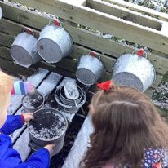
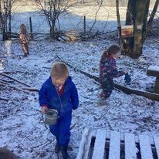
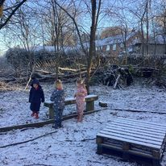
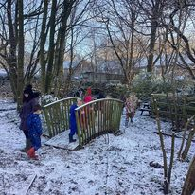
Homework
What about Homework throughout school?
Homework is always a contentious issue……..
Some parents believe that children should have lots of homework, and some believe that children should have none at all! Whilst others have all shades of opinion in between!
At Singleton, we adopt what we believe is a very sensible approach, firmly rooted in supporting the children’s learning in school and as they reach upper Key Stage 2, supporting the transition to high school.
We want the very best lifetime opportunities for our children by giving them the best possible start, and we believe this is achieved through an effective working partnership with parents.

Parents are asked to encourage their children to undertake and complete homework tasks to promote
- good attitude to work
- self-esteem and a sense of achievement
- improved standards of performance

We value the support you give to your children through discussion of their homework, and would especially ask you to ensure that your child has the time and environment in which to work undisturbed. We ask that you ensure that your child completes their homework each week. However, should there an extenuating circumstance and your child has been unable to complete the homework on time, please send in a short note explaining the reason.

What type of homework will my child get?

Reading
Infant children should be heard read by someone at home every night for 5 – 10 minutes. In school, the children are taught to read every day through phonics. At home, listening to your child read practices and reinforces what they have learnt at school. There is nothing more important that you can do at home than support your child’s reading as this unlocks the whole curriculum for them. A child that can’t read cannot access for example history or geography. All children have reading records, written in by parents and staff, and this is an effective source of communication between home and school.

As children progress through school and become independent readers, it is inappropriate for them to be reading out loud at home: we want them to become thoroughly engrossed in books. The role of the parent at this stage is to encourage, support and discuss what is being read. Children in the juniors should aim to read a minimum of 3 times a week. (Minimum of 10 – 20 minutes).

Spelling
In our school we use an online programme called IDL which is highly effective programme for improving reading and spelling. All children have their own log in details and can access this programme from home. The children all work at their own pace and level. We would encourage every child to spend 5 – 10 minutes per night on the IDL programme. (Minimum of 3 times a week is needed for the children to make any sustained progress).

Speaking and Listening
The children will receive two home projects a year – which will involve preparing and presenting a talk for the rest of the class.

Mathematics
In the infant department, the children must learn their number bonds and their times tables. These can be done through singing, on car journeys, counting lampposts, cooking, through shopping, etc. As the children move into the juniors, it is important that by Year 4, they know all their times tables, and these are just learnt through practice.
Apart from this, children will be given online homework (My Maths) every week by their class teachers, which extends or reinforces learning in class. My Maths has the option for parents and children to watch demonstrations of how to do the concept.

Other information
Children in Year 2 and Year 6 will have more homework in their run-up to the statutory testing in May.
Please encourage your child to learn at home positively. Think very carefully about the praise and criticism you give. It can be very damaging to constantly tell children they are doing something wrong.
A more positive approach is to support the children in understanding that making mistakes is a vital part of learning. Encourage them to think about what they could do differently next time and what they have learnt from the mistake.
We try very hard to build confidence, and we do this through an ethos that promotes self-belief. We encourage all our children to have a go, to understand that their talents and abilities can be developed through passion, education, and persistence. We also work with our children to help them understand that for them, it is about commitment to learning, taking risks, and learning from mistakes. In school, we correct inaccuracies that children should know and then challenge them with new learning.
We praise: -
- Effort
- Motivation
- New Learning
- Struggle and set backs
- Strategies and choices
- Choosing challenging tasks
- Improvement
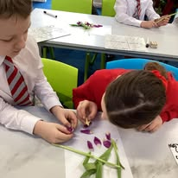
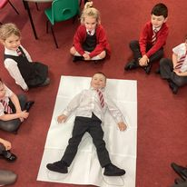
It would be helpful if you use the same approaches
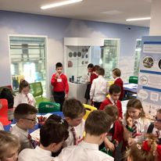
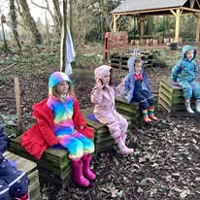
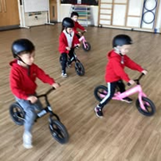
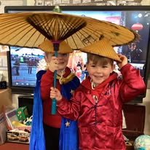
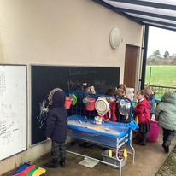
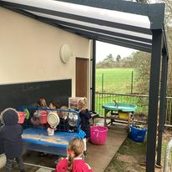

Generic whole school homework information
IDL – Specialist Literacy programme
Over the last few years, we have invested a lot of money in specific online programmes to support our children with their learning. IDL was initially designed as a dyslexic support programme for developing reading comprehension skills, spelling, and grammar. However, in more recent years, it has been highly recommended to schools for use with all children. Evidence indicates that schools that use IDL have seen pupils’ reading and spelling ages increase on average by around 10 months after just 26 hours of use.

IDL automatically generates a starting point for pupils based on their individual reading and spelling ability so children progress at their own rate.

We use IDL within our guided reading, so children access between 20 and 25 minutes of IDL in school each week. However, it is recommended that children try and complete an hour a week to get the maximum impact. It is not possible to devote an hour of the children’s timetable to IDL during school time as we have so many other subjects to address. So, we include IDL as part of our homework.

All children (Y1 –Y6) will be given a password to log on at home.

The grid below outlines a minimum expectation for IDL homework. If you wish to do more with your child in the holidays, you can log on at any time – the more levels the pupils complete, the more progress they make!

My Maths
My Maths is an online programme that we use for Maths Homework.

The homework set will always be linked to what has been taught in class and will either consolidate learning or further challenge depending on the individual needs of the child.

All children (Y1 –Y6) will be given a password to log on at home. The children will be given one piece of maths homework per week.

With My Maths, the homework has to be completed in one go. You cannot dip in and out of the homework.

In My Maths, the work is marked automatically at the end of the session so the child can see exactly what they have got wrong or right. They can have more than one attempt on a piece of homework, as new questions are generated each time. If a child is struggling, they can also watch the demonstrations to remind them which strategies they should use.

Times Table – ‘Rock Star’ online resource
We use a resource called ‘Rock Stars,’ to support with the learning of times tables. As most of you will be aware the Government have introduced a times table assessment test. Children in year 4 will now be assessed formally on their times tables.
Children will be provided with log in details and will be expected to complete their online timetables homework.
So, what are the children expected to know?

Y1/2
2x, 3x, 5x and 10x

Y3/4
2x, 3x, 4x, 5x, 6x, 7x, 8x, 9x, 10x, 11x and 12x

Y5/6
Should be secure in all times tables and should know square numbers up to 20 squared
Purple Mash
Purple Mash
You will be aware that at Singleton we use Purple Mash to support our teaching of the computing curriculum. Purple Mash is a fantastic platform that covers a wide range of subjects from the National Curriculum. All pupils in Key Stage two use Purple Mash for weekly, multiplication practice, spelling practice and also weekly reading (reading is in addition to their school reading book).
Children’s log in details for Purple Mash will be stuck in their reading planner.

Purple Mash - Spellings
Every week, children will come home with a ‘Look, cover, write and check’ sheet to work through. Once completed, they should log on to Purple Mash and complete the corresponding quiz, which will support their learning of the spellings. This will be followed up by a weekly spelling test.

Serial Mash – Reading
Every week, your child will be set a reading task from a book to read. They should read the chapter and then answer the online quiz. The children’s scores are sent back to the teachers' Purple Mash accounts.

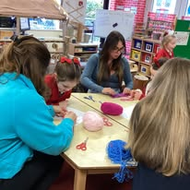
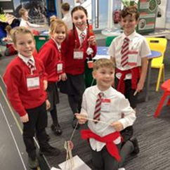

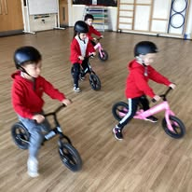
Other information
- Staff will check online homework (IDL/ABACUS/MY MATHS) is completed.
- Times tables may be tested throughout the week, but this should not affect the ongoing support with practise that you give at home.
- For Home projects/Presentations, instructions will be sent home separately.

Class | Maximum Time per day spent on homework | Daily homework | Weekly tasks |  | Homework Given out | Homework due in | Other
1/2 | 20 – 25 mins per night | 10 mins reading each night.  5 mins times tables per day Year Two only (but Year one is welcome to participate in this too) | My Math’s | 20/30mins | Friday online | Friday online | Throughout the year the children will also have:-  - Home projects will be completed in the Spring and Summer terms.  - ‘Talk’ for writing homework when relevant and linked to literacy or a Talk Project.
1/2 | 20 – 25 mins per night |  | Times tables | 20/25 mins
1/2 | 20 – 25 mins per night |  | Spellings | Daily | Friday on paper | Friday tests
1/2 | 20 – 25 mins per night |  | SPAG.com | 20/25 mins | Usually Friday’s online- I will notify you when this is set next term | Friday online
Reading book information

Books will be changed on Friday’s

Class | Maximum Time per day spent on homework | Daily homework | Weekly tasks  (Please note with IDL and tables you don’t have to do it all in one go – you can spread it out over the week.) |  | Homework Given Out | Homework due in | Other
3/4 | 25 – 35 mins per night | 10 mins reading each night  (Independent readers at least 3 times a week) | My Math’s | 20/30 mins | Usually, Friday’s online | Usually, Friday’s online | Throughout the year, the children will also have: -  - Home projects – Information will be sent out separately regarding these
3/4 | 25 – 35 mins per night |  | PURPLE MASH – times tables practice Y4 | 20 mins | Usually, Friday’s online | N/A  Just practice for Gov test in year 4.  However, yr3 can also go on and have a go.
3/4 | 25 – 35 mins per night |  | Times tables –Rock stars, Hit the button, Top marks | 20 mins | N/A | N/A
3/4 | 25 – 35 mins per night |  | IDL | 20 mins | N/A | N/A
 |  |  | Literacy- spellings | 15 mins | Usually Friday’s | Usually between Monday- Wednesday or date given | - This might be IDL, home projects, or a specific piece of work Literacy/spellings LCWC and purple mash quiz or SPAG given to the children.
 |  |  | Serial Mash | 20 mins | Usually Monday’s from 18th sept | The following Monday
Reading book information

Books will be changed on Monday’s

Home projects
- The children will be set home projects throughout the year – these are research presentations

Class | Maximum Time per day spent on homework |  | Weekly tasks | Homework Given out | Homework due in
5/6 | 35 – 45 mins per night |  | My Math’s  (20 mins) | Friday | Friday
5/6 |  |  | Serial Mash  (20 mins) | Wednesday | Wednesday  (a new chapter will be set online)
5/6 |  |  | Spelling  (20 mins) | Friday | Friday
 |  |  | Reading | 3 x 15 mins per week minimum | This is personal study and there are no set times
 |  |  | Times tables | 3 x 15 mins per week minimum | This is personal study and there are no set times
 |  |  | IDL | 3 x 15 mins per week minimum | This is personal study and there are no set times
Other |  | Throughout the year, the children will also have: -  - Presentation projects on Science and Math Topics (your child will be given a date for their project)  For Year 6, additional Homework will be sent linked to SATs preparation and also to prepare them for the demands of High school

Homework in Foundation Stage
We do not have a set pattern or rigid structure for homework within our foundation stage, as the children come into school with very individual learning needs.

Learning together is the emphasis for children in the Early Years Foundation Stage
(EYFS). The activities are literacy-based with a strong emphasis on reading together and phonics. Maths activities may be sent out as and when they are deemed appropriate.

What type of work will my child get?
Reading
In Foundation Stage, parents will be informed of the graphemes/phonemes and tricky words that the children are learning in school as they are learnt in lessons. Starting in the autumn term and continuing all year, the main emphasis is on reading at home. This should be done in two ways: -

Adults reading to children.
- Parents are encouraged to share books from their own homes, the School Library, and other Library facilities. They are also asked to share reading in the environment when it is appropriate i.e. signs and captions in the street. Parents should encourage children to point to words as they are being read. Discussion about the books is important.

Children reading to an adult.
- When they are ready to, children will start bringing simple books home to ‘read’ to an adult. Some of the books in the first term will be ‘text-less books’ – much valuable conversation and discussion can be had about the pictures and the layout of the book. Again, encouraging the child to point to the words as they are being read is important. Discussing the story and the characters and asking questions about the book will help with the child’s understanding of language.
- After ‘text-less books,’ children will receive books with words. Typically, children will receive 2 books per week.
  - One book will be fully decodable, meaning that your child will be able to segment and blend each word as these are matched to the current phonic level.
  - One book will contain ‘context words’, these are listed on the inside cover of every book. An adult should read these words for the child to copy. These ‘context words’ aim to increase vocabulary.
Tricky words.
Children learn to read tricky words as part of ‘Red Rose Letters and Sounds’ phonics scheme. Parents will be sent a list of the tricky words for each phase after the children have learned them. Regularly practising reading them, looking out for the words in reading books and playing games with them will really benefit the child. For some children, it will be useful to practise writing the words as well as reading them. The teachers may send home games to give parents some ideas. It would be useful if these words were practiced on a regular basis in the summer holiday before Year 1, as well as parents continuing to share books with their child.

Letter formation.
Children will receive letter formation cards and rhymes, which complement the Red Rose Letters and Sounds phonics scheme.

We ask that at-home parents encourage the children to write/mark make at every opportunity.
Make it fun: -
- Shopping lists
- Letters to Father Christmas/Tooth Fairy
- Writing birthday cards
- Using a clip-board to make lists of all the insects they can find in the garden
- Writing a postcard
- Writing in the sand on the beach
- Making letters and numbers out of Play-Doh

Giving children the opportunity to practise forming letters and also developing drawing skills with a variety of different tools will give them valuable practice. The important thing is to watch them and correct any mistakes sensitively so they don’t fall into bad habits.

Numeracy
We encourage parents to count with their children up to twenty and to also encourage their children to read and write numbers. Throughout the year, parents may be sent tasks linked to numeracy in class. However, there are lots of games that you can play: -

- Bingo
- Snakes and ladders
- Snap with number cards
- IPAD Apps
- Pairs – with numbers
- Looking for shapes around and about (square window, etc.)

- Money - recognising coins and counting.

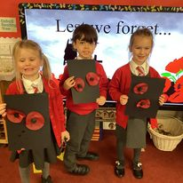

Illness
If my child becomes ill in school, what happens?
Your child will be cared for until collected. (Our First Aiders will assess and monitor your child). We will telephone you or other named contacts – please make sure to let us know if your phone numbers or family contacts change.

Immediate medical help will be sought in an emergency.
We will also phone you / or speak to you if we notice head-lice on your child. Parents are sometimes alarmed or embarrassed when this happens for the first time- please don’t be! Head lice are a common occurrence in all schools, and they are very sociable little pests. The best method of prevention is to go through your child’s hair with a nit comb and hair conditioner once a week.
What happens if there is an accident in school?
You will be contacted in the same way as if your child has become unwell. As much as we try to prevent accidents from happening and have set health and safety procedures, they do occur from time to time, as they do at home; children fall, heads get bumped, infant children still attempt to cut their own hair, etc.
We will telephone to tell you about what has happened and offer advice as to the seriousness of the incident.
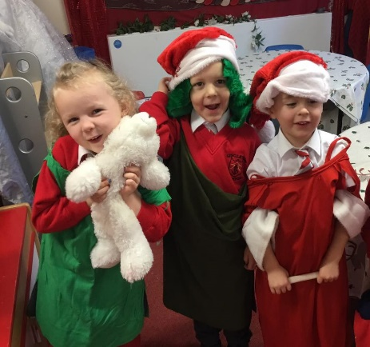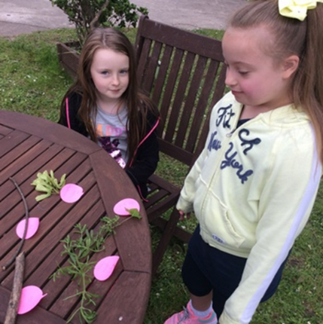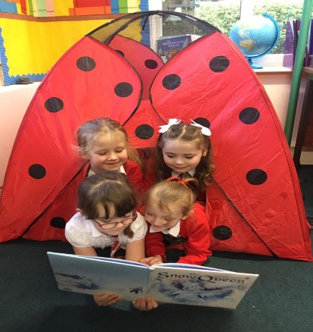
Jewellery
The guidelines from Lancashire are that no jewellery or watches can be worn for P.E.

In our school, we allow a watch and stud earrings. However, children should be able to take out the studs for P.E. themselves without assistance; if a child cannot remove their earrings, we ask that parents send them to school on the days when they have P.E. without their earrings in.

Acorns Kids Club – before and after school child care
Is there an after-school club?
At Singleton School, we have a before and after school club that is run by a 3rd party provider, ‘Acorns’.

Acorns wrap-around care club is very popular and is available from 7.30 am, and breakfast is available at this time. After school, the Acorns runs until 5.30 pm and includes a fantastic range of activities and a very popular snack time!

Opening Times
Monday 7.30 is - 8.40am 3:15 – 5:30 pm
Tuesday 7.30 am - 8.40am 3:15 – 5:30 pm
Wednesday 7.30 am - 8.40am 3:15 – 5:30 pm
Thursday 7.30 is - 8.40am 3:15 – 5:30 pm
Friday 7.30 am - 8.40am 3:15 – 5:30 pm

Booking
All booking information and links are on the school website. Please be aware that fees are subject to change. Acorns offer a 10% discount for siblings. This will automatically be deducted upon booking.
Important Information:
Staff are trained in pediatric first aid and have regular safeguarding training. We can offer the club sessions on a regular and one-off basis, although sessions will need to be booked in advance. Acorns is owned by Sarah Goldie, a fully qualified teacher of 20 years and managed by Gabby Magowan

If you are interested, please contact Sarah Goldie
Current Fees
Before School Breakfast Club | 7.30 am - 8.40 am | £5.20 per child (includes breakfast)
After School Club – full session | 3.15 pm - 5.30 pm | £9.95 per child (includes snack)
After School Club – early session | 3.15 pm - 4.15 pm | £4.95 per child (no snack)
After School Club following an extra-curriculum activity | 4.15pm - 5.30 pm | £5:45 per child (includes snack)
.


For any further enquiries, contact details are as follows:
- Sarah Goldie TEL: 07860816175
- EMAIL: sarahgoldie_uk@outlook.com

Medicine
Will you give my child medicine?
Yes, but only for an ongoing medical condition that would form part of a “care plan”.
General medicines, e.g., Calpol, cough mixtures, are not given. Parents can come to school to administer these themselves.
What about prescription medicines?

- Medicines should only be brought to school when essential and directed by a doctor (where it would be detrimental to the child’s health if the medicine were not administered during the school day);
- Parents must meet with the SENCo / Family Learning Mentor regarding the medical need to identify the next step actions for school.
- Depending on the medication or medical need, the Chair of the Health and Safety Committee may meet with parents to complete a risk assessment.
- Administration of prescribed medicines must be supported by a ‘care-plan’ developed by the School Nurse Service or GP (In conjunction with the SENCo / Family Learning Mentor).
- We do not administer antibiotics unless they are 4 X daily. If your child gets prescribed these, you need to discuss this with Mrs Clayton or the Family Learning Mentor so that appropriate arrangements can be made and consent forms signed.
- All medicines should be taken directly to the school office by a responsible adult; Medicines will only be accepted in the original container as dispensed by a pharmacist and with the prescriber’s instructions for administration;
- The medicine should be marked with the child’s name and class number;
- The appropriate dosage spoon should be included with all medicines sent to school.
- Any medicine administered will be recorded by the staff member on the medicine administration sheets in the School Office;
- Medicines will only be accepted for administration in school on completion of the appropriate form by a parent or carer. In exceptional situations, we may accept telephone consent.
P.E.
P.E. Kit
Red shorts
White polo shirt/ T-shirt
Black pumps (KS1)
Trainers (KS2)
Plain unbranded Black leggings / Plain unbranded tracksuit bottoms (Winter months)
School Hoodie (branded with school logo) (Winter Months)

On PE days, children come into school wearing their PE uniform

NB - PE kit with the school logo is available from Poulton Sport and Trophy shop – however, pupils are allowed to wear plain unbranded clothes in the correct colour as a more affordable alternative except the school hoodie. (e.g., a plain white t-shirt)

Swimming
Sensible costume (not red)
Sensible trunks (not red)
Swimming hat

Sport and involvement in physical activity play a very important part in life at Singleton School. We promote team sports and individual endeavour. We are proud of being a competitive school – we believe winning to be important, but we also balance this with an emphasis on sportsmanship, fair play, and the need to be a ‘good loser’.

We believe that sport should be for everyone and we try to offer a vast range of opportunities for children to ‘find their talent’.

Team sports, games, and other physical activities are alive and well at Singleton School. Curriculum time is allocated to addressing the requirements of the National Curriculum 2014 in full, but we also offer opportunities after school for children to take full advantage of the skills and enthusiasm provided by a dedicated and well-qualified staff.

Every opportunity is taken to compete against other schools at both a local and regional level.

Prevent Strategy
Promoting British Values at Singleton Church of England School
At Singleton Church of England Primary School, we value the diversity of backgrounds of all pupils, families, and the community. Within our curriculum, we have introduced and threaded through themes that value the perspectives of other people and other countries.

The Department for Education has recently reinforced the need “to create and enforce a clear and rigorous education on all schools to promote the fundamental British values of democracy, rule of law, individual liberty and mutual respect and tolerance of those with different faiths and beliefs”.
The Government set out its definition of British values in the 2011 ‘Prevent Strategy’, and these values have been reiterated by the Prime Minister in 2015.
The Department of Education defines British Values as follows:
- Respect for democracy and support or participation in the democratic process.
- Respect for the basis on which the law is made and applies in England.
- Support for equality of opportunity for all.
- Support and respect for the liberties of all within the law.
- Respect for the tolerance of different faiths and religious and other beliefs.

At Singleton Church of England School, these values are reinforced in the following ways:
Democracy
All pupils in Singleton Church of England School are given a voice. Children are encouraged to debate topics of interest, express their views, and make meaningful contributions to the running of the school on matters that directly involve pupils. Children have the opportunity to have their voice heard through an annual pupil questionnaire.

The principle of democracy is explored in the curriculum and assemblies. In the Autumn Term, the election of the Junior Leadership Team takes place. This is a democratic process. All children are eligible to stand. If they choose to stand, they prepare their own speech and present them to the whole school. Every child in the school is then given a vote.
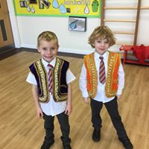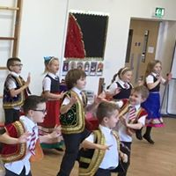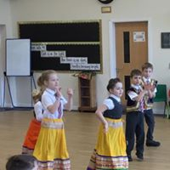
The Rule of Law
The importance of Laws, whether they be those that govern the class, the school, or the country are consistently reinforced throughout regular schooldays, as well as when dealing with behaviour and through school assemblies and worship. Pupils are taught the value and reasons behind laws, that they govern and protect us, the responsibilities that this serves and the consequences when these laws are broken. Visits from authorities such as the fire service, the police, and councillors are regular parts of the school calendar and help to reinforce these laws.

Our school rules are displayed in the main corridor and the selection of them was a democratic process. The rules and expectations are clear. Non-negotiables are evident in every classroom. At the beginning of every school year, the teaching staff and the Learning Mentor review the behaviour policy, evaluating its effectiveness and modifying it where appropriate.

The school participates in anti-bullying week. The Behaviour and Anti-bullying policy set a zero-tolerance baseline for any form of aggression, abuse, or violence, which extends to pupils and staff.

Individual Liberty
Pupils are actively encouraged to make informed choices, knowing that they are in a caring and supportive environment. Pupils are supported to develop their self-knowledge, self-esteem, and self-confidence.
Our behaviour policy is based on the principles of boundaries, choices, and taking ownership and responsibility. It encompasses rewarding positive good behaviour and promoting the idea that it’s ‘cool to be good!’ Adults in our setting lead by example. Our school Learning Mentor provides pastoral support when required.
As a school, we educate and provide boundaries for young adults to make choices safely through the provision of a safe environment and empowering situations.

Pupils are encouraged to know, understand, and exercise their rights and personal freedoms and how to exercise these safely through PSHE lessons and the curriculum. We provide opportunities to do this through choice of challenge, participation in extracurricular activities, or standing for posts of responsibility. Pupils are given the freedom to make their choices. Pupils are given key roles and responsibilities in school.

Mutual Respect
The pupils in our school have a strong belief in our Christian values: friendship, respect, trust, love, wisdom, and endeavour. We follow these values in our everyday school life. Each term, we focus on a different value, and this thread runs through the whole of our curriculum.

Our assemblies and worship incorporate these values, and our children take pride in their tolerance and respect of one another.

Tolerance of those of different faiths and beliefs.
We are a Christian school, and as such, we follow the teachings of Jesus, who taught us “to love thy Neighbour.” Multicultural activities are evident in each classroom. Multicultural activities are a strong element of the curriculum.

We respect that other people have different beliefs, and we encourage our children to develop their understanding. We support the Bethany Project in Tanzania. We are also involved with FAIR Trade.
We celebrate the festivals of other faiths, and we invite people into our school to talk to us about their different faiths and beliefs. We visit different places of worship, for example a mosque and a Buddhist temple as part of our educational visits programme Promoting British Values through our Educational Visits is our emphasis for the next two years and to promote this, we have developed a display theme in our main school corridor.

We try to encompass and thread British Values in all that we do, including celebrations, school trips, and sponsored events.

P.T.A.
In our school, our P.T.A. is called F.O.S.S. – Friends of Singleton School. We have a very strong and dedicated F.O.S.S. who has the very important role of raising additional funds, separate from our budget, which can be used to supply the school with some of the extras that we would not be able to afford. Over the past few years, F.O.S.S. has organised a range of fundraising activities from Family Fun Days to BBQs. We used this money to purchase equipment for our new wooded area, a trim trail, new interactive T.V.s in all the classrooms, STEM Challenge resources, new books for our libraries, and a range of ICT equipment. The activities of the F.O.S.S., whilst mainly aimed at fundraising and school support, do also provide a valuable opportunity for the whole school to get together on an informal basis. Extra help is always welcome, whether it is in supporting events or as a member of the committee.

Do please come and join us in this important role of raising funds for our school. New ideas are always welcome.

Pupil Premium
Since 2012, Singleton Church of England School has been able to access the ‘Pupil Premium’ grant to further support the education of its students who have claimed Free School Meals (FSM) during the previous six years. The Pupil Premium is funding in addition to the School’s budget that is used to support the attainment of the most vulnerable pupils.


At Singleton School, these funds are spent in many ways to support vulnerable families targeted by the Pupil Premium funding. Examples of how “Pupil Premium” has enhanced our provision include:
- Deploying a member of staff to the post of Learning Mentor to oversee the main outcomes and support for FSM and vulnerable children and to liaise with relevant staff who work with these particular children.
- Providing additional academic support for FSM children who need to boost progress or be challenged further.
- Providing financial support towards additional costs of education such as trips
- Providing financial support to allow every FSM child one free (normally paid for) extra-curricular activity after school per week for the whole year.
- Providing financial support towards uniform and equipment
- Additional Educational needs resources
RE / Worship
In our school, we follow the Blackburn Diocese syllabus for RE and worship, and this is threaded through all aspects of school life. We aim to develop a school where there is a prevailing generosity of spirit, a valuing of others' gifts, genuine forgiveness, cooperation, readiness to share, realistic but adventurous goals and expectations, and respect for the opinions of others

We have identified with our staff and children a set of 6 core values: Wisdom, love, respect, endurance, friendship, and trust. All members of our school community were involved in the choosing of these values and in ensuring that they are embedded in the daily life of our school.

Reverend Keighley, our Vicar, comes to school each Thursday to lead worship with the children. We take the children to Church at least once a half term and on special Sundays. We have achieved the Church School of Distinction award for our relationship with the church and the parish.
Christian values are lived out in the excellent relationships in the school family, which results in exemplary behaviour.

Worship is central to the spiritual life of the school. It is sincere, varied, and relevant and has a deep impact on the whole community.

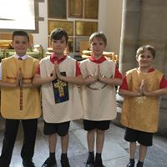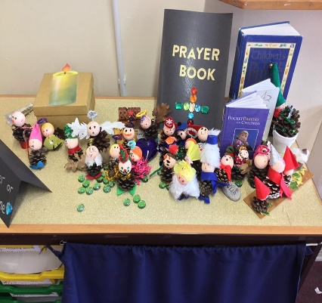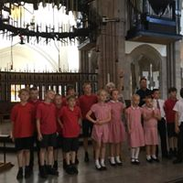
Reading
How often do you hear my child read?
In infants, children will be listened to read during guided reading, phonics (these are the sessions where we teach the children the skill to read) and also use reading books linked to the phonics sound supplemented by the Oxford reading tree scheme at least once a week by an adult in school. They will be heard read more often by support teachers or parent helpers. Please hear your child read at home every night. Reading books are NOT to be raced through and changed after the first reading. Infant books are to be read over a few days, several times, and talked about, particularly the pictures.

Junior children should still be listened to until they are reading independently. Even at this stage, it is important to ask them about books they are reading and to contact us if you have any concerns.
Please, please try not to be competitive with other parents over the “stage” of your child’s book. All children learn at different rates, and children pick up “pressure” very quickly. It is very counter-productive!

How often do you change reading books/words?
In Foundation/infants, the children’s books will be changed up to twice a week in the Foundation stage and once a week in Y1/2.

If additional words are given out to children to learn, these will be changed on an individual basis. When they can both read the words and use them in their writing, they will be changed.

Junior books will be changed when appropriate. Junior parents should be aware that they still need to hear their child read regularly – reading often dips in Years 3 and 4 because reading aloud at home has stopped!
Please encourage your child to share a variety of books with you. Share the reading experience with them, read bedtime stories, and discuss the books you read. Remember that the reading scheme in school is not the only book the children should be reading!

Reception Class – all your questions answered
What is the best way I can prepare my child for their reception year at school?
- To have good manners – say please and thank you
- To share and take turns
- To listen to adults and do what they ask
- To be able to dress/ undress themselves.
- To be independent – these children make the fastest progress.
- To not be bothered about doing everything perfectly or getting it right the first time. Children who are scared of making mistakes, or who are told that they are “not doing it right” make very slow progress.

These things are far more important than being a fluent reader at the age of 3.
Where do I leave my child in the morning and pick them up at night?
Bring your child onto the playground and wait with them until their classroom doors are opened. Each Class enters the school through their own doors. School starts at 8.40 am. Children arriving after this time have to enter school via the front entrance.

In the morning, parents are encouraged to say goodbye to their children on the playground. Collection is from the same door at 3.15 pm

How will I know what is going on in school?
Children are often reluctant to talk about their day; once home, they distance themselves from school. Mrs Clayton sends a newsletter at the beginning of every month, and this contains diary dates, news, and requests. At the beginning of each term, the class teacher sends out a curriculum letter, which gives an overview of what the children will be learning about that term. Our FACEBOOK page and Website are continuously updated and full of information.

We also send out texts and e-mails regularly.

Parents are very welcome to help in school, though not in their child’s class. (Experience has shown that this can be very unsettling for children, particularly younger ones.) Please contact the school office if you have some time to spare regularly. This is subject to DBS clearance.
Our school website has a lot of information on it and is updated regularly with news posts and information.
We also have a Facebook feed.
My child is not reading the book - they are memorising it, is this right?
This is one of the first stages of reading; however, once your child has begun their phonics journey, you should encourage them to segment and blend each word using their knowledge of the graphemes (sounds) they have been taught so far.

Why do you not always respond to everything I write in my child’s reading record?

The reading record is just a working document to indicate to us that you have heard your child read or for us to pass information on to you to further support your child’s reading. We most definitely do not want or expect you to write massive amounts of information to us in the reading record. We feel that our time is best used supporting learning in the classroom and it is a waste of valuable learning time sitting reading pages of comments in reading records and having to write large amounts of information back to you.

Our staff are at the doors in the morning and after school, and if you have something important to communicate, please just speak to them. With 15 or 30 children in a class, if we had to spend just 5 minutes responding to every comment in the reading record daily – we would with a class of 30 spend over 2 and a half hours responding to reading record comments. So do not be offended if you get no response; we prefer to pass on important information verbally when we see you!

My child writes their letters/numbers back to front - should I worry?
Do not worry at all. It is quite normal, although we would be concerned if they were still doing it in Year 6!
How should my child be forming their letters?
We use the Red Rose Letters and Sounds scheme – that is a phonics-based programme that also teaches writing. In Foundation Stage, the children learn to print, and as they move through to Year 1, they are taught the lead in and out of letters, and by Year 2, they progress to joining.

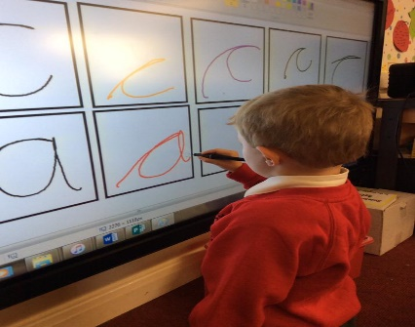
Why have you not checked my child’s bag?
We have a lot of children in our classes and it is impossible to check their bags every day. It also wastes valuable learning time! Please make sure you post any letters, money, reply slips, etc., in the drop box outside the office rather than putting them in your child’s bag. If your child has something that they need to give the teacher, please remind them. We are helping them to become independent.

Will you put sun cream on my child?
Yes, but please label the bottle with your child’s name and send a letter of consent with the name of the product you wish to use. It is better if you can put sun cream on your child after you’ve washed them, first thing in the morning.

Does my child have a buddy?
Every child will have a Year 5 buddy whom they can see at playtime for support.
My child has lost his/her sweatshirt; where is it?
Your child’s clothing should be marked (remember biro comes off in the wash and you will need to re-apply regularly). We encourage children to be responsible for their belongings. Often, children put the wrong sweatshirt on after PE and will bring it back the next day. We have a lost property box that is located in the entrance to the school, outside the office. If your child has lost something and it is not in the lost property box, then please ask Mr Lythgoe, our Site Supervisor, as he is brilliant at finding things!

My child has come home bruised. Why has this happened?
If this is a case of bullying, then it is very serious. However, a large part of development during the Reception Year is learning to exist, socialise, and make friends with a larger group of children. Reception children are rather like puppies in a pack! They literally crawl and tumble over each other outside, and we have to train them not to!

Tools/ Scissors/ Knives and Forks
From Foundation Stage, children have access to a range of tools and implements and are taught how to use them properly – and responsibly. (This is part of the statutory Foundation Stage curriculum.) Whilst children are supervised at all times, we do not stand over them; if children use them incorrectly, we see this as an opportunity to reinforce the message of correct usage.

What is Baseline Assessment?
Within the first six weeks of school, your child will be assessed using the DFE ‘s Reception Baseline Assessments produced by the Standards and Testing Agency as well as making internal judgements using Development Matters materials. Ms Rund will assess each child with evidence that backs up her judgements. They will be assessed throughout the Reception year and at the end of the school year. An Assessment Profile is completed for each child, which is purely teacher assessment and is constantly part of the teaching and learning process throughout their time in Foundation Stage. Evidence of pupil progress against the Early Learning Goals is kept by Ms Rund.

Safeguarding
At Singleton School, we recognise that providing the best possible opportunities for our children to achieve their very best is at the forefront of what we do daily. However, we also take very seriously our responsibilities in terms of the health and welfare of our children.
Our school fully recognises the contribution it can make to protect children and support pupils in school.
There are three main elements to our Child Protection Policy.

(a) Prevention:
Creating a positive school atmosphere, teaching and pastoral support to pupils where children have opportunities to have a voice and that their wishes and feelings are listened to and taken into account.

(b) Protection:
By following agreed procedures, ensuring staff are trained to recognise possible signs and symptoms of abuse and are trained and supported to respond appropriately and sensitively to child protection concerns.

(c) Support:
To pupils and school staff and to children who may have been abused.

Mrs Clayton, Miss Manns, Mrs James and Mrs Millward receive ‘Designated Senior Person ‘training every 2 years, and all other staff and governors receive full Safeguarding training every 3 years.

Mrs Reeves (Office Manager) keeps and maintains a log of all staff and volunteers who have DBS clearance to work with children which the Governors review, and monitor general safeguarding in school monthly. Mrs Clayton writes an annual safeguarding report for Mr Davies – our Chair of Governors and named Governor for child protection.

Our Safeguarding Policy and Internet Safety Policy are available for parents to view in the Policies section of the website.

We all have a responsibility to keep children safe, and there have been cases at our school where parents other than those of the child concerned have reported concerns. Any adults living in our locality who have child protection concerns should contact Social Services; -

- The Customer Service Centre 0300 123 6720
- Emergency Duty Team (Out of Hours) 0300 123 6721/3

Or, alternatively, contact the police.

Parents need to understand that Mrs Clayton, Mrs Millward, Miss Manns, Mrs James, the staff, and the governors have a statutory responsibility to refer any safeguarding concerns to the Lancashire Safeguarding Team.

Our policy is to ‘Put the child First’, and this means we seek advice if there is even a small amount of doubt or concern. This can, and has on many occasions, led to uncomfortable conversations with parents and carers, but we would rather be safe than sorry, and the needs of our children are paramount.

School Hours

Please note that classroom doors open at 8.40 am, and children are welcomed into the classroom at this time, where activities are provided.
- We open the doors earlier to aid with congestion and parking, but it should be noted that children should not be on the school site before 8:40 am unless they are booked into breakfast club.

Morning session
8.40am – 12 noon (Foundation Stage & KS1)
8.40am – 12.20 pm (KS2)

Afternoon session
1.00 pm – 3.15 pm (Whole school)

Please ensure that children arrive promptly each day. Parents are asked to drop children off on the playground and let them come into school alone to avoid congestion/foster independence, and ensure the safety of the children. All classes have their entry point, and a member of the staff team is available at each entry point before and after school.

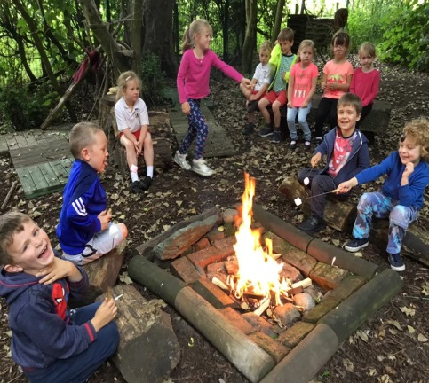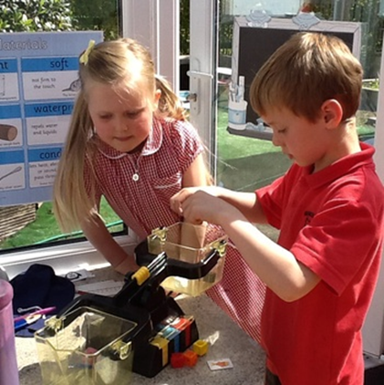

SEN & Pastoral support
All children are valued, respected, and welcomed to our school, whatever the level of their educational or physical ability. We seek to support all children in their learning and ensure they have equal access to all areas of school life. The SEN code of practice (2001) recognises that there are 4 broad areas of SEN:

- Communication and interaction (language and autism spectrum disorder).
- Cognition and learning (general learning and specific learning difficulties).
- Physical and sensory.
- Behavioural, emotional and social.

We seek to identify and assess the special needs of individual pupils using a variety of assessment techniques and working in co-operation with the pupils, parents, teaching staff, and external agencies. We are able to provide an environment that enables access for all pupils regardless of their need. Our accessibility plan enables optimum participation in the school community for pupils and prospective pupils with a disability.

Pupils with SEN are placed on our SEN register at an appropriate level, and teachers differentiate for their needs in each lesson, through Individual Education Plans (IEP’s) or in some cases Statements of SEN. This provision and register is regularly reviewed by the SEN co-ordinator and the Head Teacher. Parents of pupils on the SEN register are invited to school termly to review their child’s current IEP and progress.

Within our school, we also have a Family Learning Mentor. The Family Learning Mentor works within the school to help children and families with any difficulties they may be experiencing. They are there to listen and offer support and practical advice. They are informal educators.

A Family Learning Mentor is here to:
- Listen
- Offer support
- Promote positive behaviour
- Offer encouragement and build self-esteem and confidence
- Identify the barriers to learning and set targets.

Who does the Family Learning Mentor work with?
- Individuals and groups of children
- Teachers and other members of staff, i.e., support/welfare staff
- Parents/carers
- Schools
- External agencies such as Social Services, Police, Health Professionals, Education Welfare Service, Sure Start, School Doctor/Nurse.

The Role of the Family Learning Mentor

For Children:
- Build confidence, raise self-esteem, and motivation
- Improving social skills and forming relationships with friends, family, and staff
- Improve attendance and punctuality
- Remove barriers to learning
- Help children to achieve their potential
For Families:
- Improve support and communication between home and school
- Access to outside agencies and someone to talk to in confidence
For school:
- More effective and efficient communication between parents/carers, teachers, and outside agencies
- Reduction in anti-social behaviour

At our school, we implement the award-winning myHappymind programme to support children's mental health and well-being.
Delivered by class teachers through five engaging modules, the programme helps children understand their brains, celebrate their strengths, develop gratitude, build positive relationships, and set meaningful goals.
Using an innovative technology platform, myHappymind makes learning easy and fun for all children from Early Years to Year 6, including those who are neuro-diverse or have special educational needs.

Swimming
This takes place in Year 3 and Year 4 each year, we are allocated a time slot by Poulton YMCA. Children require a towel and swimming costume.
- All children with long hair should either wear bathing caps or have their hair tied back if the teacher considers the length of the hair to constitute a health hazard.
- Jewellery should not be worn in the pool.
Parents who wish their children to wear goggles need to ask at the school office for an authorisation form.
Any children who cannot swim 25 metres when they enter year 6 will go for additional swimming lessons as the government has outlined that this is now a statutory requirement of primary schools.
Trips
Does My Child Have to Go on The School Trip?
Yes. School Visits have been carefully considered to enhance the curriculum and take part in statutory school time. There is a charge for visits to cover costs, but parents experiencing difficulties can always approach Mrs Clayton / Mrs Reeves in confidence if they are having problems paying.

Risk assessments are always done beforehand, and there are set pupil/adult ratios to observe.

A qualified first-aider always accompanies school visits.

If I am worried or unhappy about something, what should I do?
In the first instance, talk to your child’s Class Teacher or The Family Learning Mentor, depending on the nature of the worry or concern. We have an open-door policy and would rather you talked to us than worry at home.

We build up warm and trusting relationships with families in school, and we are always ready to listen. The best time to see class teachers is after school rather than in the morning, as all teachers are busy preparing for the day in the time before school starts. (Please be aware that all staff run after-school activities, so try to avoid those nights.)

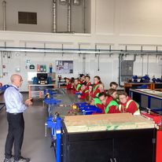
If you need to talk to a teacher, please phone the office for an appointment or wait for the staff to release all the children at 3.15 p.m. before you try to speak to them about your child. All children must be handed over safely and without distraction.
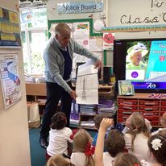
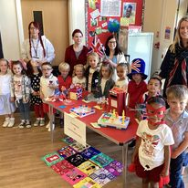

Useful Details
If you need to get in touch with us at any time, our address, phone number, and e-mail contacts are as follows:-

Singleton Church of England Primary School
Church Road
Singleton
Poulton–le–Fylde
FY6 8LN

Tel 01253 882226
E mail head@singleton.lancs.sch.uk
Website www.singleton.lancs.sch.uk

Uniform
It is important for our children to develop pride in their appearance and identify with school. We ask that children have appropriate hairstyles, and if they have long hair, it is tied back for school.

- Please ensure that all items of clothing are clearly marked with your child’s name and that P.E kits are available in school at all times.
- The Sports and Trophy Centre in Poulton-le-Fylde supplies all our school uniform.
Our School Uniform Policy
Winter Summer

Girls
Grey skirt/ pinafore Red / white check dress
White blouse Red logoed cardigan
White socks or grey/ red tights Smart sensible black shoes – not trainers
Smart sensible black shoes – not trainers White socks or grey
Red Fleece (optional)
Red/grey striped tie
Red logoed cardigan
Suitable Coat

Boys
Grey trousers Grey shorts
Grey/ black socks Red V-necked logoed jumper
White cotton shirt Red Polo shirt or white shirt with tie
Red / grey striped tie Smart sensible black shoes – not trainers
Smart, sensible black shoes – not trainers
Red V-necked logoed jumper
Red Fleece (optional)
Suitable coat

Please note
- All infant children need a red Singleton School book bag. (No other bags are allowed)
- KS2 children can bring a bag of their choice and a pencil case
- Reception Class – will require puddle suits and wellies for outdoor learning, to kept in school.
NB
In the winter months, there is an expectation that all children bring an appropriate coat to school to wear during outdoor play sessions. This is in line with Lancashire Safeguarding recommendations, which specifically say children must have adequate clothing.
Children will not be allowed out to play without a suitable coat.

P.E. Kit
Red shorts
White polo shirt/ T-shirt
Black pumps (KS1)
Trainers (KS2)
Plain unbranded Black leggings / Plain unbranded tracksuit bottoms (Winter months)
School Hoodie (branded with school logo)– (Winter Months)

On PE days children come into school wearing their PE uniform

NB - PE kit with the school logo is available from Poulton Sport and Trophy shop – however, pupils are allowed to wear plain unbranded clothes in the correct colour as a more affordable alternative with the exception of the school hoodie. (e.g., a plain white t-shirt)

Swimming
Sensible costume (not red)
Sensible trunks (not red)
Swimming hat

