Subject: Science | Programme of Study: Cycle A |  | Y3/4
Lower Key Stage 2: Year Three  Plants  Pupils should be taught to:  - identify and describe the functions of different parts of flowering plants: roots, stem/trunk, leaves and flowers  - explore the requirements of plants for life and growth (air, light, water, nutrients from soil, and room to grow) and how they vary from plant to plant  - investigate the way in which water is transported within plants  - explore the part that flowers play in the life cycle of flowering plants, including pollination, seed formation and seed dispersal  Animals, including humans  Pupils should be taught to:  - identify that animals, including humans, need the right types and amount of nutrition, and that they cannot make their own food; they get nutrition from what they eat  - identify that humans and some other animals have skeletons and muscles for support, protection and movement  Rocks  Pupils should be taught to:  - compare and group together different kinds of rocks on the basis of their appearance and simple physical properties  - describe in simple terms how fossils are formed when things that have lived are trapped within rock  - recognise that soils are made from rocks and organic matter  Light  Pupils should be taught to:  - recognise that they need light in order to see things and that dark is the absence of light  - notice that light is reflected from surfaces  - recognise that light from the sun can be dangerous and that there are ways to protect their eyes  - recognise that shadows are formed when the light from a light source is blocked by an opaque object  - find patterns in the way that the size of shadows change  Forces and magnets  - compare how things move on different surfaces  - notice that some forces need contact between 2 objects, but magnetic forces can act at a distance  - observe how magnets attract or repel each other and attract some materials and not others  - compare and group together a variety of everyday materials on the basis of whether they are attracted to a magnet, and identify some magnetic materials  - describe magnets as having 2 poles  - predict whether 2 magnets will attract or repel each other, depending on which poles are facing |  | Lower Key stage 2: Year Four  Living things and their habitats  Pupils should be taught to:  - recognise that living things can be grouped in a variety of ways  - explore and use classification keys to help group, identify and name a variety of living things in their local and wider environment  - recognise that environments can change and that this can sometimes pose dangers to living things  Animals, including humans  Pupils should be taught to:  - describe the simple functions of the basic parts of the digestive system in humans  - identify the different types of teeth in humans and their simple functions  - construct and interpret a variety of food chains, identifying producers, predators and prey  States of matter  Pupils should be taught to:  - compare and group materials together, according to whether they are solids, liquids or gases  - observe that some materials change state when they are heated or cooled, and measure or research the temperature at which this happens in degrees Celsius (°C)  - identify the part played by evaporation and condensation in the water cycle and associate the rate of evaporation with temperature  Sound  Pupils should be taught to:  - identify how sounds are made, associating some of them with something vibrating  - recognise that vibrations from sounds travel through a medium to the ear  - find patterns between the pitch of a sound and features of the object that produced it  - find patterns between the volume of a sound and the strength of the vibrations that produced it  - recognise that sounds get fainter as the distance from the sound source increases  Electricity  Pupils should be taught to:  - identify common appliances that run on electricity  - construct a simple series electrical circuit, identifying and naming its basic parts, including cells, wires, bulbs, switches and buzzers  - identify whether or not a lamp will light in a simple series circuit, based on whether or not the lamp is part of a complete loop with a battery  - recognise that a switch opens and closes a circuit and associate this with whether or not a lamp lights in a simple series circuit  - recognise some common conductors and insulators, and associate metals with being good conductors

TOPIC 6: THE BIG BUILD (Y4) | Summer 2 | Subject knowledge | Working Scientifically  (Not all lessons will cover this) | Notes on children.  Insert initials into EXC and EM. It can be assumed that all other chn are working at expected.
Lesson 1: Bridging a stream (p.79) | - Set up simple practical enquiries, comparative and fair tests.  - Make systematic and careful observations and, where appropriate, take accurate measurements using standard units, using a range of equipment, including thermometers and data loggers.  - Record findings using simple scientific language, drawings, labelled diagrams, keys, bar charts and tables Use results to draw simple conclusions, make predictions for new values, suggest improvements and raise further questions.  - Use straightforward scientific evidence to answer questions or to support their findings. |  | Em. Children carry out a simple comparative test between the bridges and say which collapsed and which did not.
Lesson 1: Bridging a stream (p.79) |  |  | Exp. Children use results from their fair test to draw conclusions using their data.
Lesson 1: Bridging a stream (p.79) |  |  | Exc. Children apply what they have learned to extend their test and refine their bridges.

TOPIC 6: THE BIG BUILD (Y4)  ) | Summer 2 | Subject knowledge | Working Scientifically  (Not all lessons will cover this) | Notes on children.  Insert initials into EXC and EM. It can be assumed that all other chn are working at expected.
Lesson 2 Which shape is the strongest for bridge pillars? (p.80) | - Set up simple practical enquiries, comparative and fair tests.  - Make systematic and careful observations and, where appropriate, take accurate measurements using standard units, using a range of equipment, including thermometers and data loggers  - . Record findings using simple scientific language, drawings, labelled diagrams, keys, bar charts and tables. Use straightforward scientific evidence to answer questions or to support their findings |  | Em. Children carry out a comparative not a fair test.
 |  |  | Exp. Children carry out a fair test and use their graph results to answer the question.
 |  |  | Exc. Children use their results to ask new questions, e.g. does the height of the pillar affect the strength

TOPIC 6: THE BIG BUILD (Y4) | Summer 2 | Subject knowledge | Working Scientifically  (Not all lessons will cover this) | Notes on children.  Insert initials into EXC and EM. It can be assumed that all other chn are working at expected.
Lesson3: Terrific Triangles (pg. 81) | - Set up simple practical enquiries, comparative and fair tests.  - Use straightforward scientific evidence to answer questions or to support their findings. |  | Em. Children make and compare the different shapes with and without triangles, they can say what happened.
Lesson3: Terrific Triangles (pg. 81) |  |  | Exp. Children use their observations from comparative tests to say why triangles are used in the bridge.
Lesson3: Terrific Triangles (pg. 81) |  |  | Exc. Children use their results to ask and answer new questions

TOPIC 6: THE BIG BUILD (Y4) | Summer 2 | Subject knowledge | Working Scientifically  (Not all lessons will cover this) | Notes on children.  Insert initials into EXC and EM. It can be assumed that all other chn are working at expected.
Lesson 4: Spaghetti Towers (pg.83) | - Set up simple practical enquiries, comparative and fair tests  - Make systematic and careful observations and, where appropriate, take accurate measurements using standard units, using a range of equipment, including thermometers and data loggers  - Use results to draw simple conclusions, make predictions for new values, suggest improvements and raise further questions |  | Em. Children build a tower without applying prior experiences.
Lesson 4: Spaghetti Towers (pg.83) |  |  | Exp. Children apply their understanding of structures and learn as they build.
Lesson 4: Spaghetti Towers (pg.83) |  |  | Exc. Children organise their project using prior experience to create basic shapes which are strong to build their tower.

TOPIC 6: THE BIG BUILD (Y4) | Summer 2 | Subject knowledge | Working Scientifically  (Not all lessons will cover this) | Notes on children.  Insert initials into EXC and EM. It can be assumed that all other chn are working at expected.
Lesson 5: Researching Big Builds (pg. 86) | - Ask relevant questions and using different types of scientific enquiries to answer them.  - Report on findings from enquiries, including oral and written explanations, displays or presentations of results and conclusions |  | Em. With support, children ask questions about a bridge or tower building and use limited resources to answer questions.
Lesson 5: Researching Big Builds (pg. 86) |  |  | Exp. Children ask and answer a range of questions and write up their answers.
Lesson 5: Researching Big Builds (pg. 86) |  |  | Exc. Children ask and answer additional questions that arise as they research.

TOPIC 6: THE BIG BUILD (Y4) | Summer 2 | Subject knowledge | Working Scientifically  (Not all lessons will cover this) | Notes on children.  Insert initials into EXC and EM. It can be assumed that all other chn are working at expected.
Lesson 6: Big Build- Newspaper Bridge or Tower (pg.87) | - Set up simple practical enquiries, comparative and fair tests. Record findings using simple scientific language, drawings, labelled diagrams, keys, bar charts and tables  - Use straightforward scientific evidence to answer questions or to support their findings.  . |  | Em. Children participate in a group to make and test a structure and require help to work with data from the whole class test.
Lesson 6: Big Build- Newspaper Bridge or Tower (pg.87) |  |  | Exp. Children test their structure and use the graphed data to draw conclusions.
Lesson 6: Big Build- Newspaper Bridge or Tower (pg.87) |  |  | Exc. Children test their structure and use the graphed data to draw conclusions and suggest improvements to the process.

Subject Knowledge  (Rising Stars) | Bridges and towers can be made from many different materials such as wood, stone, bricks, iron and steel even plastic and glass fibre can be used. The material a bridge is made from is important but so is the shape, a material can be made stronger by changing its shape. Good shapes for bridges are arches and triangles. The reason triangles are so strong is that their shape is fixed, the angles cannot be changed once they have been made. However in squares and rectangles the angles can be changed – using pieces of card fixed with paper fasteners helps to show this. Bridges are essential for transport networks to be developed and not only to cross obstacles such as rivers, bays, gorges and canyons, but to join communities. The earliest bridges were beam bridges probably inspired by trees that had fallen over streams or gullys. This type of bridge requires the material laid across the gap to be strong and not bend or sag when a load (person, vehicle) is placed on it. When making bridges using paper or card a single sheet will not be a strong bridge, add a curved piece of card or paper underneath the bridge (an arch) then the structure resists the forces making the card beam bend. If a load, for example a weight, is placed on top of an arched bridge, the force of the load pushing down is transferred to the sides of the arch which push outwards. The pillars or, for example, river bank, push back and so the bridge does not collapse. Triangles are very strong structures, so if a beam across a bridge is made using triangles then it will be strong. Children changing card or paper so that it is pleated like a fan can use this to make a structure that holds a greater load. Common types of bridges include beam bridges, arch bridges, suspension bridges, cantilever bridges, truss bridges and cable-stayed bridges. The type of bridge depends on what they are to be used for, cost and the ground where they are built. Historical bridge designers such as Isambard Kingdom Brunel and Thomas Telford created bridges, canals and tunnels without the technology we have today. However, even bridges built with modern technology can have problems as in the case of the Millennium Bridge which wobbled when lots of people were using the bridge at the same time. Bridge disasters There have been many famous bridge disasters such as the Tay Bridge in Scotland. On 28th December 1879, the central spans of the Tay bridge collapsed into the Firth of Tay, 75 people died because the bridge structure could not withstand gale force winds. The Tacoma Bridge disaster in 1940 was also caused by wind, causing the whole bridge to vibrate and twist, there are many video clips online showing this happening. Why are towers built? Towers are built because on the ground they take up very little space, but they can have a lot of floor space because the floors are built one on top of the other. So a tower will cover a small area on the ground but have over 100 floors which is a lot of space. More people can live or work in a tower compared to buildings that are only a couple of storeys high. Engineers Structural engineers design structures such as bridges, tunnels and buildings. The work with architects who design these structures, it is the structural engineer’s job to make sure that the materials used, and the design can withstand forces such as the load (e.g. cars, people, trains) as well as wind, rain and even earthquakes. The structural engineer’s role is to make sure that the building or bridge is safe
“LET’S THINK LIKE SCIENTISTS”  Use these questions to develop research skills and speaking and listening | Why do people build bridges? Who built the first bridges? What kind of bridges are there where you live? Where would you build a bridge? Why? Who do you think works on building a bridge? What jobs do they do? | What problems do you think structural engineers would have building towers? When you have built towers when playing what problems did you have? Do you think that people who build towers need to know about science? Why? | What would you have to do to become a structural engineer? Why does a structural engineer need to have scientific understanding about rocks, soils, forces, earthquakes, the weather? If you were a structural engineer, what would you like to build?
Working Scientifically Skills | Lower KS2 Programmes of Study  Working Scientifically:  During years 3 and 4, pupils should be taught to use the following practical scientific methods, processes and skills through the teaching of the programme of study content:  - asking relevant questions and using different types of scientific enquiries to answer them  - setting up simple practical enquiries, comparative and fair tests  - making systematic and careful observations and, where appropriate, taking accurate measurements using standard units, using a range of equipment, including thermometers and data loggers  - gathering, recording, classifying and presenting data in a variety of ways to help in answering questions  - recording findings using simple scientific language, drawings, labelled diagrams, keys, bar charts, and tables  - reporting on findings from enquiries, including oral and written explanations, displays or presentations of results and conclusions  - using results to draw simple conclusions, make predictions for new values, suggest improvements and raise further questions  - identifying differences, similarities or changes related to simple scientific ideas and processes  - using straightforward scientific evidence to answer questions or to support their findings.
Key Vocabulary | 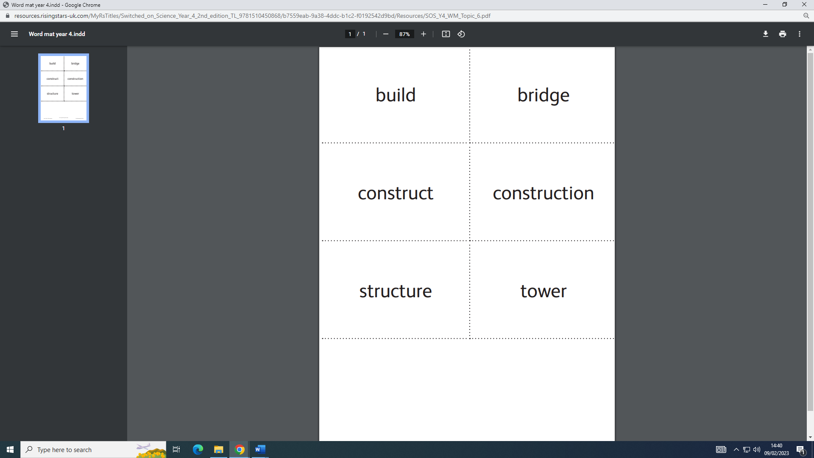
Cultural Capital Opportunities   | Invite into class Civil engineer, structural engineer, builder or architect.  -STEM ambassadors from the construction industry. Representative from the Local Authority Highways Primary Engineers https://www.primaryengineer. com/  Visit  -A local construction site. Local bridges to take photographs and study structures.  -A local quarry that takes visits from primary pupils

Assessment notes / evaluation – include SEN / PP next step learning and areas that need more focus

Year 3 | Working below expectations | Working within Expected Standard | Working above expected
Target | 14 – 20%  (no more than 2 children) | 80 %- 86% | 20%
Term 1
Term 2
Term 3

Year 4 | Working below expectations | Working within Expected Standard | Working above expected
Target | 14 – 20%  (no more than 2 children) | 80 %- 86% | 20%
Term 1
Term 2
Term 3

